Teacher Preparation Notes for “Comparing Mitosis and Meiosis”

In this minds-on analysis and discussion activity, students review mitosis and meiosis as they compare and contrast meiosis and mitosis. This activity includes an optional mitosis and meiosis card sort for additional review.

I recommend that, before your students begin this activity, you have them complete either these two analysis and discussion activities,
- "Mitosis and the Cell Cycle – How the Trillions of Cells in a Human Body Developed from a Single Cell"
- “Understanding How Genes Are Inherited via Meiosis and Fertilization”
or these two hands-on activities,
- “Mitosis and the Cell Cycle – How a Single Cell Develops into the Trillions of Cells in a Human Body”
- “Meiosis and Fertilization – Understanding How Genes Are Inherited”.

Instructional Suggestions and Background Information
To maximize student learning and participation, I recommend that you have students work in pairs to answer each group of related questions. Student learning is increased when students discuss scientific concepts to develop answers to challenging questions; furthermore, students who actively contribute to the development of conceptual understanding and answers to questions gain the most. After pairs of students have worked together to answer a group of related questions, I recommend that you have a class discussion to probe student thinking and help students develop a sound understanding of the concepts and information covered.

If your students are learning online, I recommend that they use the Google Doc version of the Student Handout available at https://serendipstudio.org/exchange/bioactivities/MitosisMeiosisC.To answer questions 2-3, students can either print the relevant pages, draw on those and send you pictures, or they will need to know how to modify a drawing online. They can double-click on the relevant drawing in the Google Doc, which will open a drawing window. Then, they can use the editing tools to add lines, shapes, and text boxes. If you are using the Word version of the Student Handout to make revisions, please check the PDF version to make sure that all figures and formatting are displayed properly in the Word version on your computer.

If you would like to have a key with the answers to the questions in the Student Handout, please send a message to iwaldron@upenn.edu. The following paragraphs provide additional background information and instructional suggestions.

If your students need to begin with a review of mitosis and meiosis, you can:
- show the brief videos “A Great Mitosis Video” and “Meiosis”, at https://www.youtube.com/watch?v=AhgRhXl7w_g and https://www.youtube.com/watch?v=D1_-mQS_FZ0, respectively
- show the 6-minute video, “Mitosis vs. Meiosis: Side-By-Side Comparison” at https://www.youtube.com/watch?v=zrKdz93WlVk or
- have them click on the PRINTABLE VERSION button under “How Cells Divide” at http://www.pbs.org/wgbh/nova/body/how-cells-divide.html#
The latter two resources include the phases of mitosis and meiosis.

Some similarities between mitosis and meiosis are:
- Before mitosis or meiosis, the DNA is replicated to form two copies of the original DNA.
- At the beginning of mitosis or meiosis, the replicated DNA is condensed into a pair of sister chromatids in each chromosome.
- In both mitosis and meiosis, spindle fibers line up the chromosomes in the middle of the cell.
- At the end of each cell division, cytokinesis forms two daughter cells.

Some differences between mitosis and meiosis are:

Characteristic | Mitosis | Meiosis
Produces: | 2 diploid body cells | 4 haploid gametes
# and type of cell divisions | 1; separates sister chromatids | 2; the first division separates pairs of homologous chromosomes and the second division separates sister chromatids
Genetic makeup of daughter cells | Identical with each other and the original cell | Different from original cell and  from each other

The following excerpt illustrates one effect of the different ways that chromosomes line up at the beginning of meiosis I vs. mitosis.
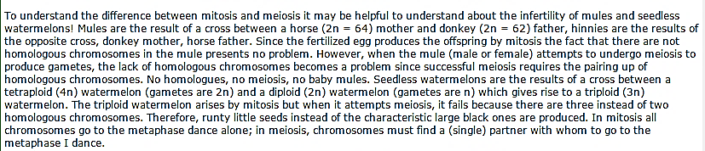
(http://carolguze.com/text/442-3-cell_cycle_mitosis_meiosis.shtml)

Optional Mitosis and Meiosis Card Sort
You can use this card sort as a supplement after question 2. Give each pair of students a shuffled deck of the stages of mitosis and meiosis and have them arrange the cards in a sequence that shows the steps that occur during mitosis and a separate sequence that shows the steps that occur during meiosis.

You can prepare the 10-card decks by cutting copies of the last page of these Teacher Notes. For easier future identification of the cards that belong together in a deck, print each deck on a different color heavy paper or card stock or use a different colored marker to make stripes down the outside edges of each deck. After students finish this card sort activity, you will want to ask them to shuffle each deck thoroughly to provide a challenge for the students in the next class.

Follow-Up and Related Activities
I recommend that this activity be followed by one of our introductory genetics activities:
- Genetics (https://serendipstudio.org/sci_edu/waldron/#genetics) or
- Introduction to Genetics – Similarities and Differences Between Family Members (https://serendipstudio.org/exchange/bioactivities/geneticsFR).
These activities are part of an integrated sequence of learning activities for teaching genetics, presented in "Genetics – Major Concepts and Learning Activities" (available at https://serendipstudio.org/exchange/bioactivities/GeneticsConcepts).

A Mitosis, Meiosis and Fertilization Vocabulary Game to reinforce learning of relevant vocabulary is available at https://serendipstudio.org/exchange/bioactivities/mmfvocabgame.

Sources for Figures in the Student Handout
- Figure on the top of page 1 modified from source similar to https://i.pinimg.com/736x/d9/ba/19/d9ba196121c59daf57ca71fc2e4e7106--compare-and-contrast-visual-aids.jpg
- Figure on page 2 modified from https://ohioplants.org/wp-content/uploads/2017/08/Slide43-720x540.jpg

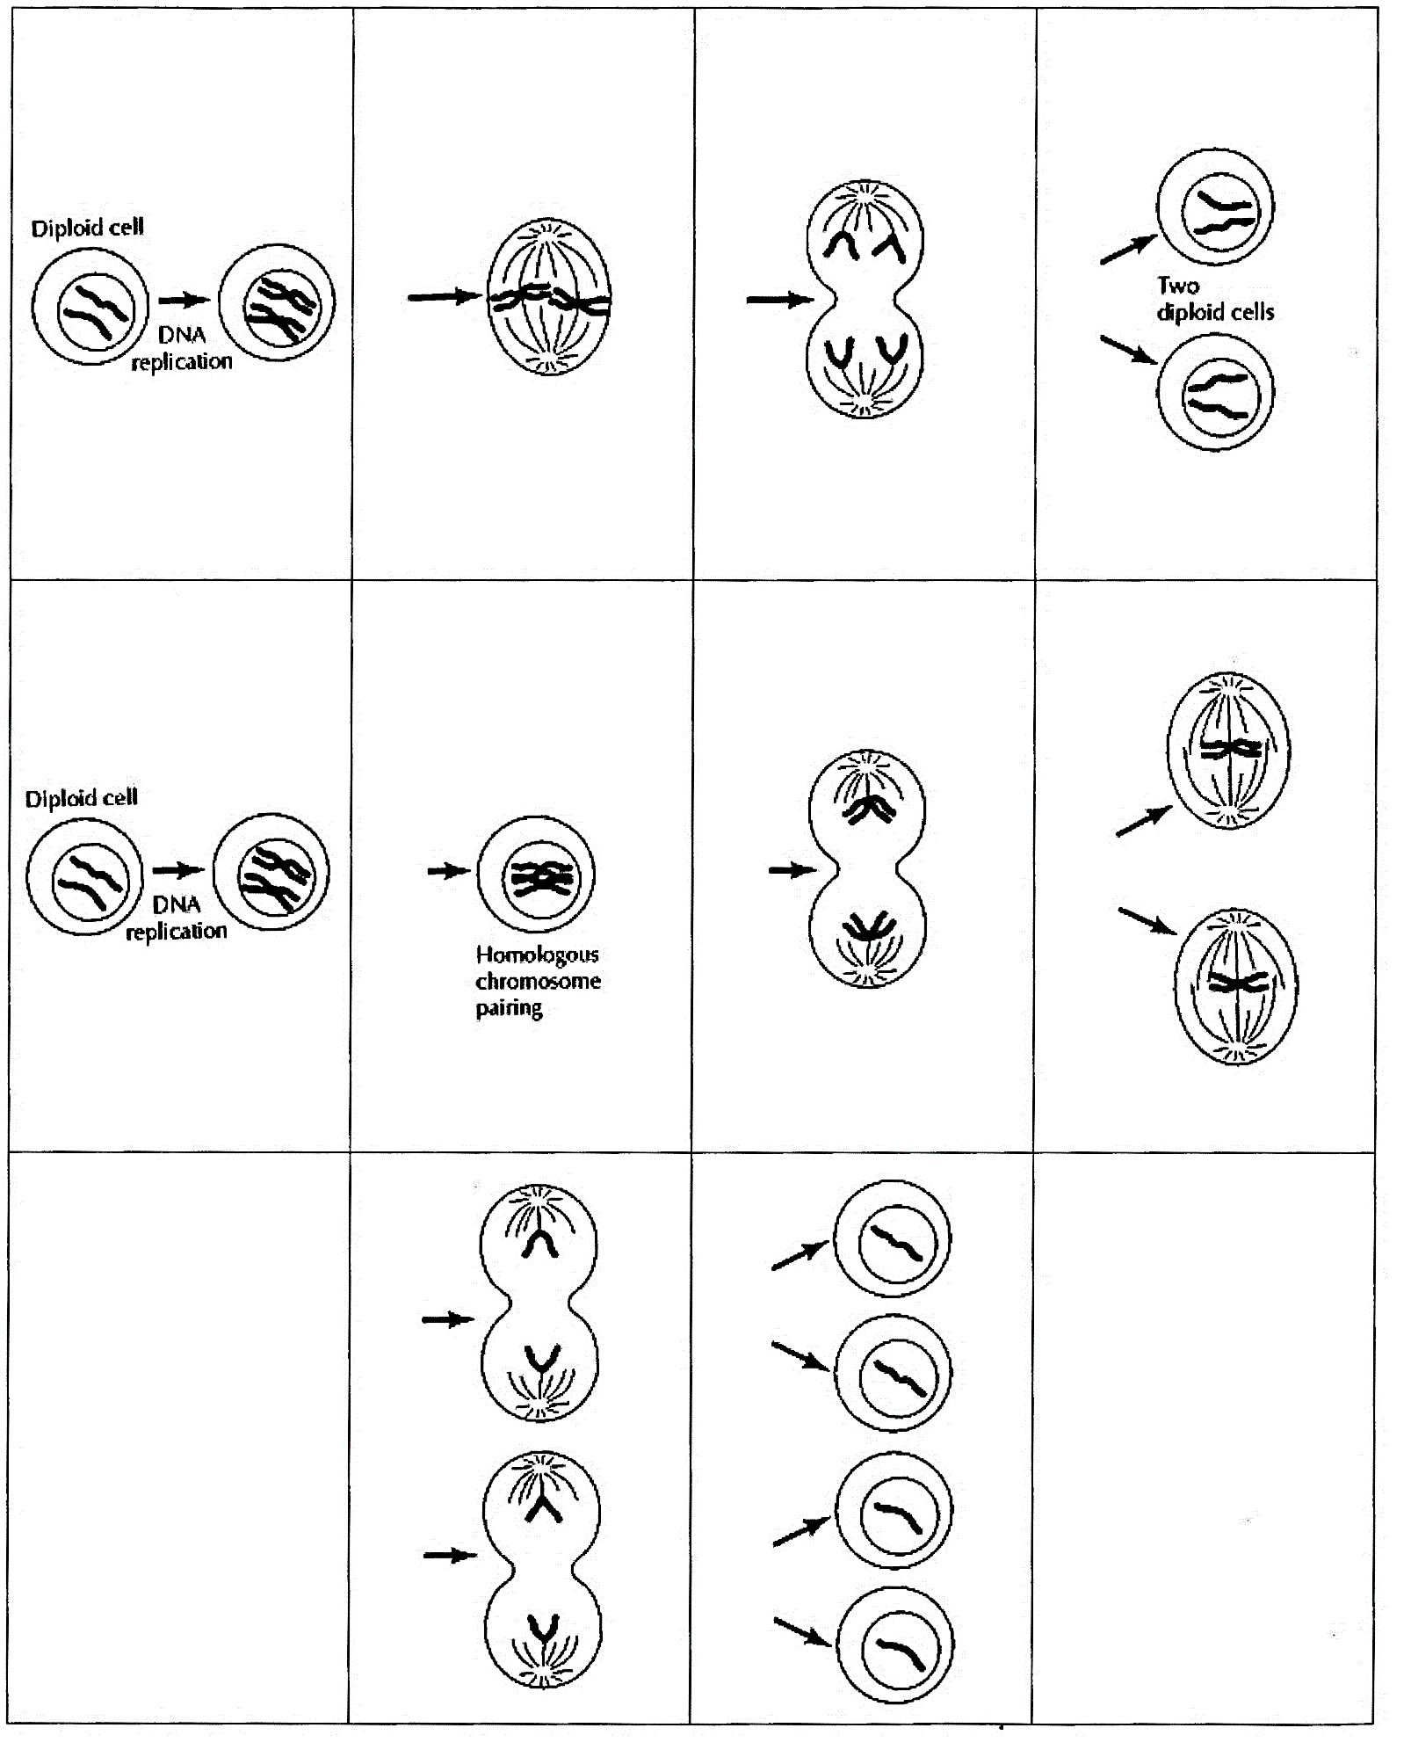
(adapted from G. M. Cooper, 2000, The Cell, A Molecular Approach)

By Dr. Ingrid Waldron, Department of Biology, University of Pennsylvania, 2022. These Teacher Notes and the Student Handout are available at https://serendipstudio.org/exchange/bioactivities/MitosisMeiosisC
https://education.asu.edu/sites/default/files/the_role_of_collaborative_interactions_versus_individual_construction_on_students_learning_of_engineering_concepts.pdf
To draw a shape - At the top of the page, find and click Shape. - Choose the shape you want to use. - Click and drag on the canvas to draw your shape. To insert text - At the top of the page, click Insert. - To place text inside a box or confined area, click Text Box and drag it to where you want it. - Type your text. - You can select, resize and format the word art or text box, or apply styles like bold or italics to the text. When you are done, click Save and Close.

